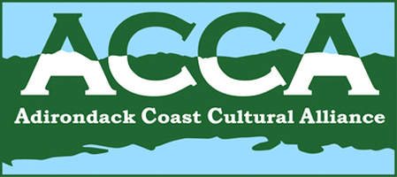

ACCA Meeting, Thursday, October 8, 2015
8:30 a.m. at the Schuyler Falls Town Hall, Morrisonville NY

AGENDA

- Sign in/Introductions

- Secretary’s Report and approval of minutes

- Financial Report

- Coordinator’s Report
Art in the Adirondacks Regional Calendar
NYSCulturalEd.org
Adopt an Attraction Feedback from Lyon Mountain Railroad and Mining Museum
New Professional Development Opportunities Webpage on adkcoastcultural.org
NYS Council for the Humanities – Grant Workshop, Plattsburgh (October 23rd)
NYS Council for the Arts DEC - Grant Applications Due (October 26th)
Pomeroy Foundation Historic Marker Grant Program – Legends and Lore (October 31st)

- Old Business

Kristy Kennedy – Chamber of Commerce/Adirondack Coast Visitors Bureau Updates

New York State History Month (November)

Lake Champlain Weekly—please sign up for November, December, and January!

- New Business

Report from CVNHP International Summit

New York State Women’s Suffrage Centennial (2017)

Passport prize drawing

- Museum Reports

Upcoming dates: Adirondack Coast Wine, Cider, and Beer Festival (Oct. 10); Conservation Workshop Reminder (October 16); CCHA 70th Anniversary Party and Fundraiser (Oct. 24) Chamber of Commerce Customer Service Seminars (November 4th)

Next meeting:

