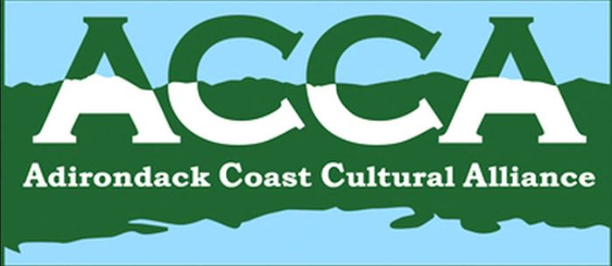
Minutes of the Adirondack Coast Cultural Alliance Meeting,
April 10, 2014

John Krueger, VP, filling in for vacationing chair Ricky Laurin, called the meeting to order at 8:07 AM on Thursday, April 10, 2014 at CCHA (Clinton County Historical Association & Museum), Plattsburgh, NY. Present were Amanda Palmer (The Alice), Amber Parliament (Chamber, Visitors Bureau), Bill Glidden (Plattsburgh Town), Samantha Bellinger (PSU Art Museum), Don Wickman (KDL), Julie Dowd (CCHA, NNYACGS), Geri Favreau (CCHA), Helen Nerska (CCHA, NCUGRHA), John Krueger (City, LCBP+), Barb Benkwitt (SF Town), and Melissa Peck (ACCA Coordinator & CCHA)

Welcome and Introductions – done!

Secretary’s Report/Minutes Approval –
Minutes of the March 20, 2014 meeting had been emailed and also provided at the meeting. Sam moved, Don seconded. Minutes approved.

Coordinator’s Report – Melissa Peck
Melissa has renewed the domain name, and is posting events on the website (please use the form on the website). The form for the Press-Republican for Museum Days is due back to Melissa by May 12 latest.

Financial Report/Approval –
Financial report Jan 1 through Apr 12 2014 was provided, income was ‘dues’ from Lyon Mountain, and remainder of coordinator grant from CVNHP for $750. Current balance $915.39. Question raised on how much more money needed. Response – At this time, just $ for coordinator. Amanda moved, Helen seconded. Financial report approved.

Passport/Chamber/Day of Caring Update – Amber Parliament
- Amber reported that the Passport for ACCA and Museum Days should be available by May 20. Either 5500 or 7500 booklets have been ordered.
Decide on Passport distribution process at next ACCA meeting.
- Hospitality training is May 28 at the PSU Art Museum.
- Day of Caring – 7 museums used volunteers, no further info
- 1812 Bike Trail is promo’d in the April 13th Press-Republican; on goadirondack.com website
- The new promo is the “Adirondack Coast Chair” project, where a painted chair will be sited in different locations around the area between May 3 and October 11, with props to draw attention to events and attractions. Check it out at #AdirondackCoastChair on FB, Twitter, Instagram

Program Update – Barb Benkwitt
- Mayor’s Cup and Macdonough Monument Tours – need volunteers for Saturday July 12.
- Yearly calendar still in process….

FY 2015 CVNHP Workplan Discussion – John Krueger
John reviewed the process LCBP and CVNHP uses to determine initiatives and funds needed each year. The Champlain Valley National Heritage Partnership (CVNHP) was a concept in 2006, and in May 2011 the plan was formally approved by the Federal Government, as part of the National Park Service (NPS), in the Department of the Interior (DOI or US-DOI), and overseen by the Lake Champlain Basin Program (LCBP), with most funding from the EPA and Great Lakes Fisheries. LCBP has several advisory committees, including the Heritage Area Program Advisory Committee (HAPAC- includes John Krueger and Amanda Palmer among others) which provides implementation advice to the LCBP Steering Committee. It is this time of year when funding is requested for FY2015 projects. SO – every April/May the HAPAC gathers ideas from stakeholders (all of us in all of the regions served by LCBP), and in June the Chair of HAPAC goes to the LCBP Steering Committee and so on and so on up to the International Heritage Program on September 15 and then in ~December the LCBP knows what funds they have available, so finally in February, 2015 they will vote on what projects get funded. THUS – we and all other stakeholder groups must identify NOW projects for the future. John said that each constituent should figure out and decide on their projects – you know what you want – and contribute ideas. Ideas included more/better signage, taking programs to students who would not otherwise be exposed to those programs; the Brainstorming list of initial ideas is attached. Jim Brangan of LCBP will be at the May meeting so all voices should be heard then, for 2015.

Other Business
- NCUGRHA (Helen) – The museum officially opens for the season on May 3rd weekend.
- Valcour Island (Helen) – The Valcour Island Trail Guide is now available!
- RP Historical (Geri) – Soft opening on Museum Weekend for the Village History Center.
- The Alice (Amanda) – May 8 is archeological talk (rescheduled from snow postponement). May 24 - Dr. Southwick Car Collection will be on display, May 25 - Chazy Memorial Day Parade with the Chapel and Mausoleum open. Amanda also shared that she will be leaving The Alice in order to concentrate more on her art. (We will miss you yet wish you all the best!)
- KDL (Don) – The conserved/restored paintings will be unveiled April 24. The Secret Garden tour is July 12.
- PSU Art (Sam) –April 12 is BFA Art Exhibit opening and ‘Slow Art Day’. April 29 Folk Art Luncheon. May 3rd Girl Scout Day.
- CCHA (Melissa) – The new exhibit opens April 12. April 19 is Textile Conservation and Collections Care workshop. May 3 is the opening of the Catholic Summer School exhibit with Roger Black’s Monday night lecture on it on May 5. May 17th is Town/Cemeteries tour of Schuyler Falls; May 31 is a Chazy tour.
- Public Historians (Barb) – Friday, June 6th at the Holiday Inn/Plattsburgh is the APHNYS Conference on Battle of Plattsburgh & Commemoration, from 9:30 am – 3:30 pm. All are welcome; registration fee includes lunch.

Next meeting –- Thursday, May 8, 2014, 8:00 AM
Clinton County Historical Association/Museum, 98 Ohio Ave (Old Base), Plattsburgh, (518) 561-0340

Motion to adjourn by Don; seconded by Amanda. Meeting adjourned at 9:13 AM.

Respectfully submitted,

Barb

Barb Benkwitt
ACCA Recording Secretary

