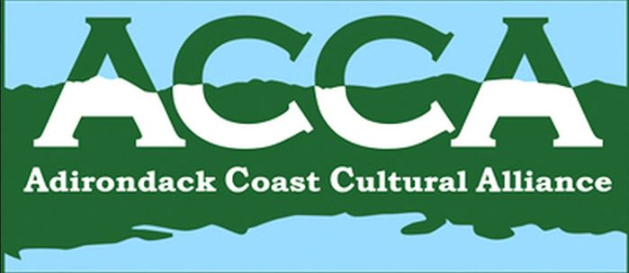
Minutes of the Adirondack Coast Cultural Alliance Meeting,
May 8, 2014

Chair Ricky Laurin called the meeting to order at 8:07 AM on Thursday, May 8, 2014 at CCHA (Clinton County Historical Association & Museum), Plattsburgh, NY. Present were Jim Brangan (LCBP,CVNHP), Ellen Adams (The Alice), Amber Parliament (Chamber, Visitors Bureau), Dave Deno (BOPA/PAFBM), Bill Glidden (Plattsburgh Town), Jane Saxe-Kelting (LMMRR), Jackie Madison (NCUGRHA), Don Wickman (KDL), Helen Nerska (CCHA), Julie Dowd (NNYACGS, CCHA), Ricky Laurin (ACCA+), John Krueger (City, LCBP+), Barb Benkwitt (SF Town), and Melissa Peck (ACCA Coordinator & CCHA)

Welcome – done! No intros needed….

Secretary’s Report/Minutes Approval –
Minutes of the April 10, 2014 meeting had been emailed and also provided at the meeting. John moved, Bill & Don seconded. Minutes approved.

Financial Report/Approval –
Financial report Jan 1 through Apr 30 2014 was provided. Current balance $765.39. Helen moved, Don seconded. Financial report approved.

Coordinator’s Report – Melissa Peck
Submit information to Melissa by May 12 for inclusion in the Press-Republican listing. 5 groups have submitted so far. Any questions about Museum Days – contact Melissa. Hospitality Training 9 am May 28 at Myers Fine Arts; Barb, Rick and Julie volunteered.

CVNHP Grant Ideas/Workplan Discussion for FY2015 – Jim Brangan
Brainstorming topics from previous meeting had been distributed. Jim reviewed the Champlain Valley National Heritage Partnership (CVNHP) which includes 10 regional stakeholder groups (like ACCA), and stretches from the Canadian border South to Warrensburg (the Hudson Hoosick Region) and all of Western Vermont. The budget ranges from $300K up to $1M. The grant timetable runs from April 2014 to February 2015. In June 2014 emerging issues are identified culled from stakeholder meetings like this, then taken to a September heritage summit with representatives from NY, VT, and Quebec, then further up the chain to a budget in February, 2015. There are some initiatives which continue year to year – the heritage summit, regional stakeholder coordination grants, and wayside exhibit rehabilitation grants. Others reflect new initiatives, such as the Lake Champlain Bridge interpretive panels growing to a bi-state park; easily-accessible outstanding geologic sites/roadside geology; water trails engaging youth in, for example, Shelburne Bay; sustainable agriculture; Battle of Plattsburgh legacy/Fort Brown access; Civil War conference in NY in June 2011 and in Vermont November 2014; and long boat expansion from the Lake Champlain Maritime Museum to Plattsburgh.

For 2015-2016 individual or competitive grants, ideas tossed about included World War I; Education (rural one-room schoolhouses); Women’s Suffrage; Prohibition; Transportation/Railroads; Industrial History. Sean Moore and Larry Gooley might be resources for Prohibition. For Education, taking a trunk of resources to schools is an idea. Important to link to the Core Curriculum. Possible local heritage grant with a focus on education could include kids doing documentaries on local heritage. A conference on education could showcase kids and interviews they’ve done. Museums and schools could be encouraged to apply for such grants. Jim will also keep us posted on other groups’ input.

Updates from the Group
LCBP/Jim Brangan – Has some plexiglass shelves. Contact him for more info. Mini-grant may be available.
City/John Krueger - There is a new Downtown group on which John sits that has gotten $15K from the county for 100 interpretive signs to develop a trail like the Boston Freedom Trail. Committee is headed by Colin Read, and includes (besides John) Jim Bailey, Kristy Kennedy, Matt Boire. Anastasia Pratt (County Historian) will ‘vet’ the sites. Sites could include the Champlain Monument, Plattsburgh Academy, the railroad station in an historic trail. Let the minutes read that ACCA supports bilingual signs. All are welcome on Tuesdays at 5:15pm at the Champlain Wine Company.
Passport/Chamber/Amber Parliament The Passport for ACCA and Museum Days should be available late May. Amber will call people to pick up Passports for their organization and/or deliver to others. Hospitality training is May 28 at the PSU Art Museum. Boot camps are being scheduled. Send your events to Amber to post on the Chamber site. A group is already slated to use the War of 1812 Bike Route. The Saranac River Trail app (bilingual) is in process (Jesse Fielder?). Geocaching geotours will be starting. We’ll ‘roundup’ Museum Days at the next meeting. Bring feedback.
KDL/ Don Wickman The recent reception was a success. KDL is open. A new book in lake history has been published by the VT Historical Society.
PAFB/Dave Deno Grand opening 11 AM June 7. John Stone will speak.
UGR/Jackie Madison Don Papson’s book on Secret Lives is complete. There will be a Fall book signing.
CCHA/Melissa Schuyler Falls Cemetery/Town tour May 17. Valcour Island opens May 25. Chazy History tour May 31. Helen Nerska speaks at the Base Chapel June 2nd on Charles Luther Hagar, her relative. John Krueger and Jan McCormick will be leading tours of the Old Base monthly beginning in June.
Lyon Mountain/Jane A fund-raiser breakfast is May 11 from 8-12.
ACCA/APHNYS Barb Benkwitt June 6 at the Holiday Inn is a day-long conference on the Battle of Plattsburgh. All are welcome. Volunteers needed for Mayor’s Cup and Macdonough Monument Tours on Saturday July 12.

Next meeting –- Thursday, June 12, 2014, 8:00 AM
Clinton County Historical Association/Museum, 98 Ohio Ave (Old Base), Plattsburgh, (518) 561-0340

Motion to adjourn by Jim; seconded by Jane. Meeting adjourned at 9:45 AM.

Respectfully submitted,

Barb

Barb Benkwitt
ACCA Recording Secretary

