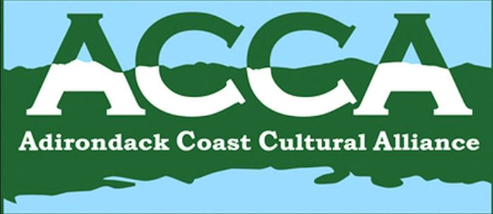
Minutes of the Adirondack Coast Cultural Alliance Meeting,
December 8, 2016

President Ellen Adams called the meeting to order at 8:33am, Thursday, December 8, 2016 in the upstairs meeting room at the Alice T. Miner Museum in Chazy. Thanks for hosting, for goodies and tour afterwards!
Present: Ellen Adams (Alice T. Miner Museum, ACCA president), Barb Benkwitt (Schuyler Falls Town), Julie Dowd (CCHA, NNYACGS), Whitney Jackson (ADK History Museum, E-town), John Krueger (City Historian, CVNHP), Ricky Laurin (ATM, CCRS, community, past-president), Helen Nerska (CCHA), Melissa Peck (ACCA coordinator), Alina Walentowicz (Chamber/Visitors Bureau).

The minutes of the November 10th meeting were approved on motion (Ricky motioned, John seconded).
Alina reminded all that membership fees are due, as email was sent by Melissa.. No changes in financial position. Year –end financial report will be prepared.
Melissa’s coordinator’s report – Items of interest continue to be forwarded as received. The Dec 7 email from Humanities NYS seeks suffrage input for weekly articles in an online newspaper from Seneca Falls. Another provided a link to ‘New World for Non-Profits” and possible changes in Board responsibilities. The CVHN minutes included collaboration on suffrage events. At the HAPAC meeting of LCBP/CVNHP the work plan was updated. Ellen will represent ACCA at the meetings; February is budget time.
Old Business –
ACCA Membership – reminder to send payment to the Chamber noted as ACCA. This will provide extra funding for ACCA events such as Museum Weekend and likely NYS History Month. Note that HAPAC is looking at Interpretive grants regarding the suffrage 100th anniversaries in 2017 and 2020.
Proposed new committees – a handout was provided (attached and forwarded also via email) describing form and function of 3 committees for member involvement in the coming year. Thanks to Ellen for formulating. A motion to establish these three committees – Passport, Outreach and Events – was made by Helen, seconded by Rick, with positive discussion. Motion was passed unanimously. Volunteers or suggested members so far are for Passport – Rick Laurin, Jane Saxe-Kelting, and for Events – Alina Walentowicz and Ellen Adams. Usually 3 members would work for each committee – contact Ellen to volunteer. [Ed. Note – email sent by Melissa December 14 inviting responses.] Also, a new Vice President is needed to replace Samantha Bellinger. Contact Ellen to volunteer.
Calendar Planning - Destination Master Plan - John mentioned that he understood the consultants would be back in the Plattsburgh area April 6-7 so that would be a great opportunity to meet and share updates. More info to follow.
Lake Champlain Weekly ‘Museum Corner’ articles – Helen will take January; Ellen will connect with Jackie Madison for February; March will focus on Suffrage and there will be weekly articles; April, May and June are still open. Whitney will take a month in the Spring for ADK History Museum. Other volunteers?
ACCA Coloring Books – Following up on previous discussions, we talked about how to get more coloring books out into the public. The books are held at the Chamber, and can be obtained by contacting Alina. One restaurant had obtained some for their patrons. The idea of a volume discount was suggested. Barb moved, Melissa seconded a motion that a purchase of 100 coloring books or more would be sold at 25 cents per copy (rather than 50 cents). Motion passed unanimously.
New Business –
2016 Passport Drawing - Four entries were received completed, and 2 mostly done. It was decided to draw first and second place from among those fully complete, and third prize from those mostly (and non-winners for prizes 1 and 2). Passport winners for 2016 are: First Prize – John Higgins, Plattsburgh; Second Prize – Barb & Gillian Miner of Morrisonville; Third Prize – Kay Branagan of West Chazy. Congratulations to all; Melissa or Ellen will contact them and ensure they get their prizes.

Museum Reports –
Alice T. Miner Museum – The holiday open house was a great success with over 60 people attending. January 19 is a Brewing Up History event to be held at the Alice T. Miner Museum with a speaker from Valcour Brewing Company. [Ellen]
Clinton County Historical Association/Museum – The museum is open from 10-3; the open house is December 10th. A suffrage lecture series is being planned, to be held in various community locations. Looking for people to research and present. Contact Helen if interested. [Helen]
Kent Delord House Museum – Reminder that the Delord Christmas is December 8th evening. [Message sent by Don who was busy preparing for same]
Visitors Bureau – Keep sending events to the Visitors Bureau! [Alina]
French History Connections – Ricky shared that on April 1 a small group will gather at the home of David Graham – including Ricky’s family – as an off shoot of the French heritage meetings – to share a potluck supper, songs and more. He will keep us posted as the time draws near, and as to how this might start an ongoing series! [Rick]

Ellen mentioned that she would miss the next meeting - Thursday, January 12. There being no other business, meeting adjourned 9:28 am.

NEXT MEETING –
Thursday, December 12, 8:30am – Schuyler Falls Town Hall, 997 Mason St, Morrisonville NY (South off Route 22B after crossing the ‘new’ Morrisonville bridge, if coming from Plattsburgh Route 3 to straight on 22B)

Respectfully submitted,
Barb
Barb Benkwitt
Secretary, ACCA

